BAR CHART - PRODUCT INVENTORY QUANTITY
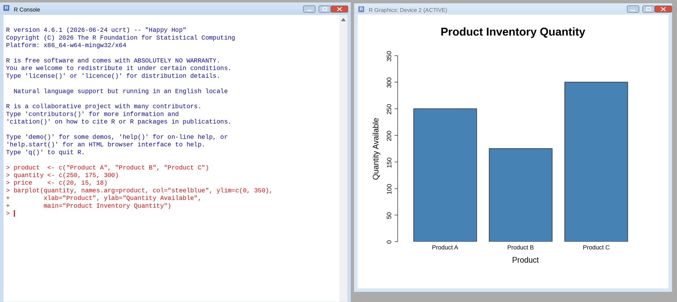

STACKED BAR CHART - INVENTORY QUANTITY BY CATEGORY
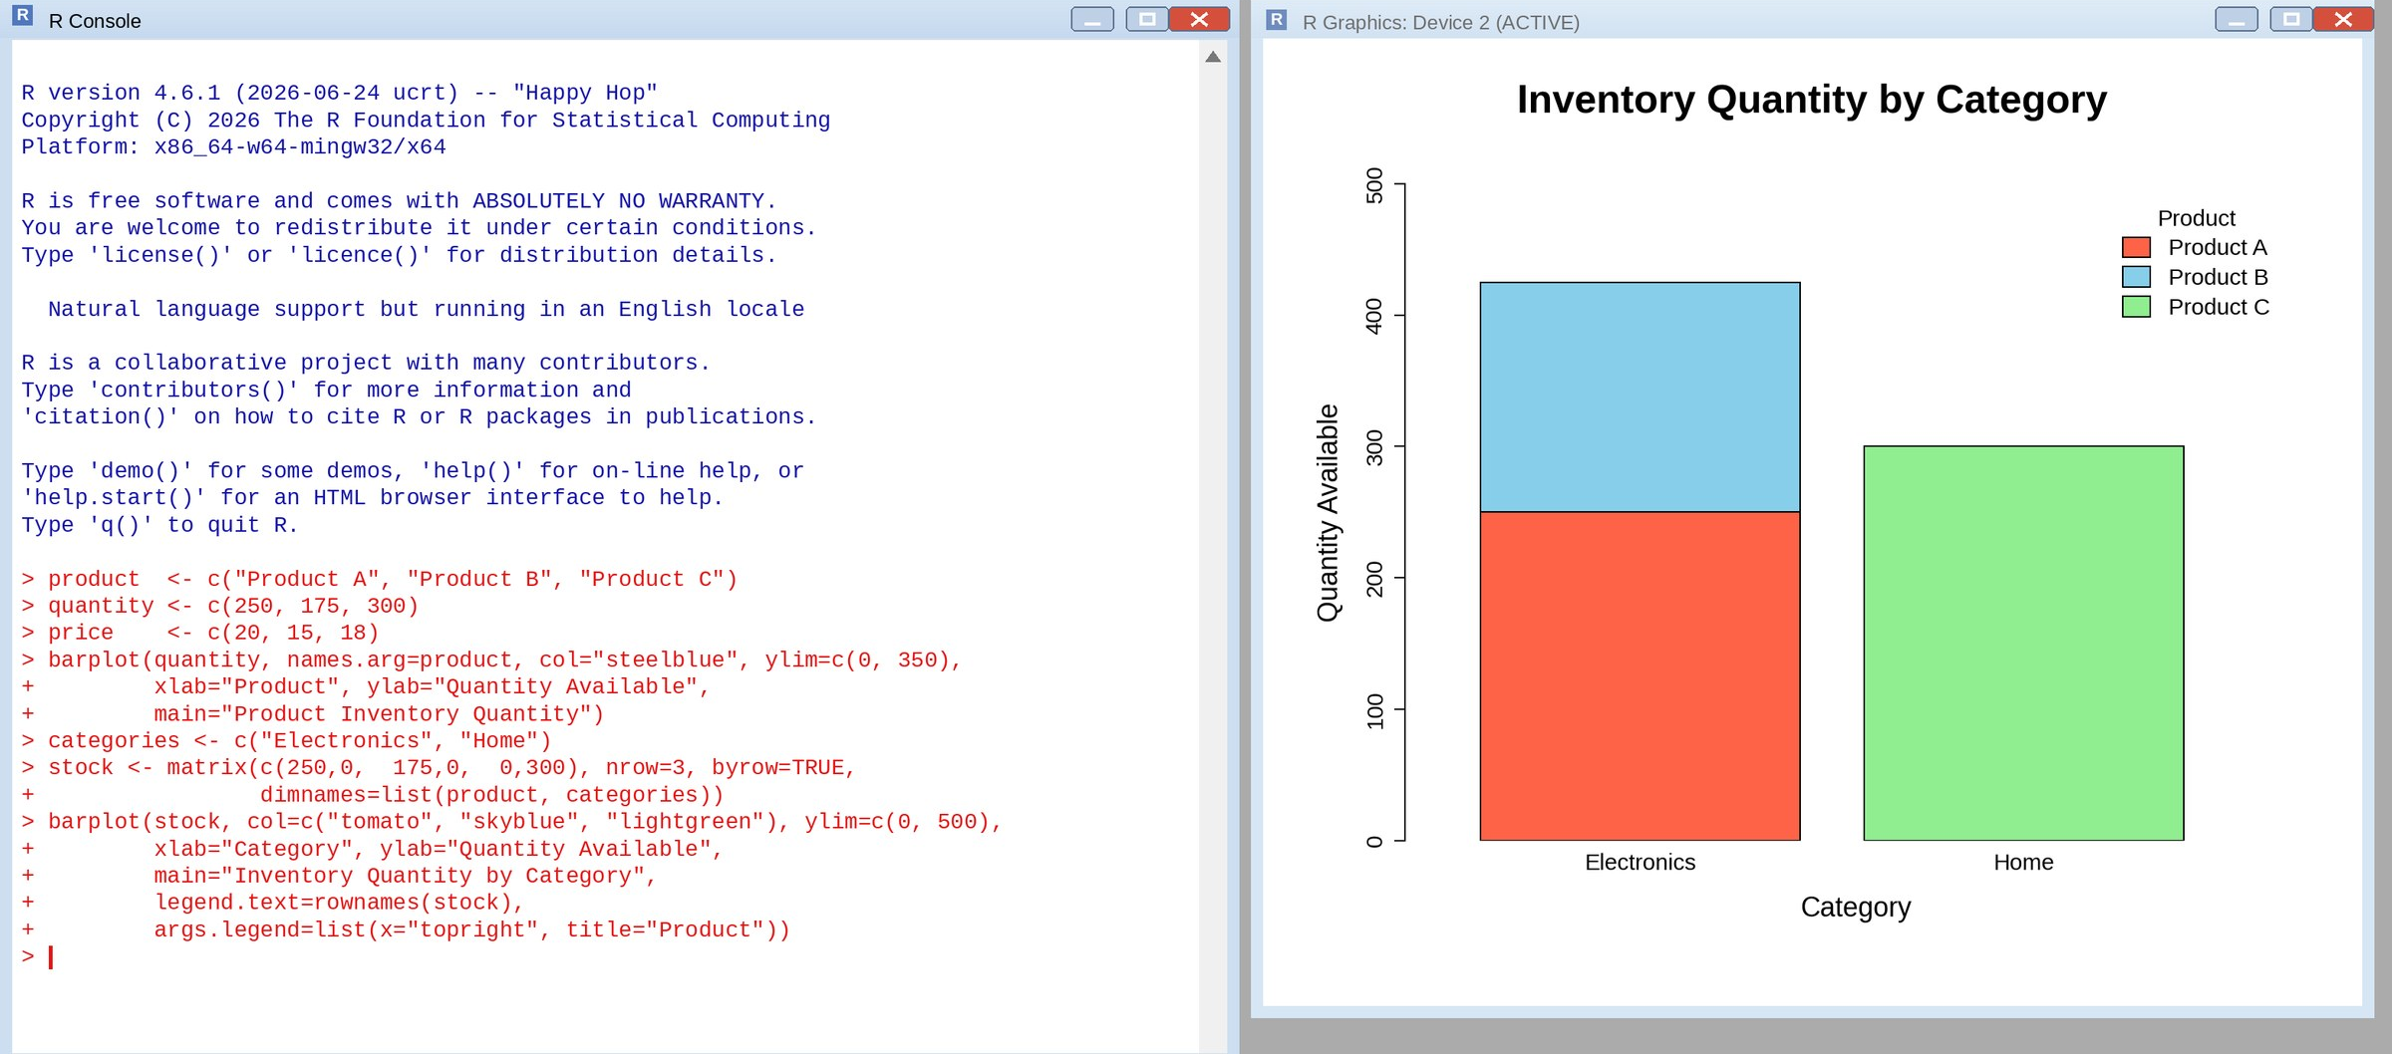
TABLE - PRODUCT INVENTORY DATA
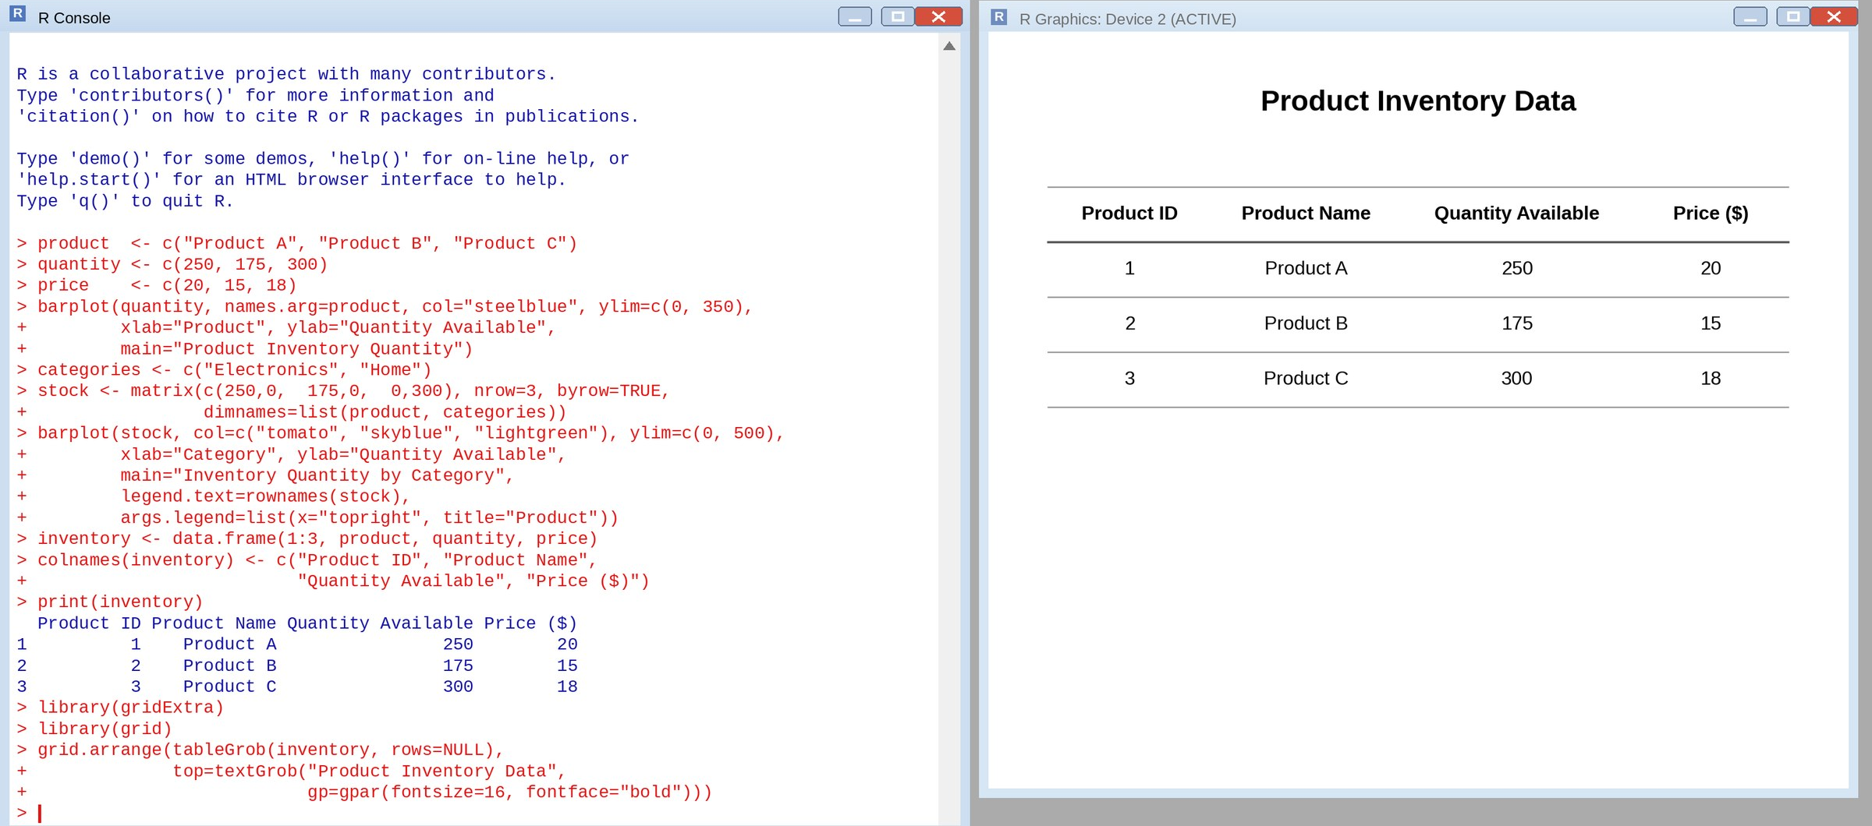

TABLEAU DASHBOARD - BAR CHART, STACKED BAR CHART AND TABLE
